# Tracking Issues and Exchanging Information in GitHub

Bonnie Smithson 1/10/15

In an effort to be efficient as we approach a deadline, we can use some tools that are provided with our GitHub repository: namely the issues tracker and the Wiki. If you bring up your desktop GitHub Dashboard, you will find these options on the right side.

## Tracking Tasks, Bugs, Feature Requests, Goals, and Milestones

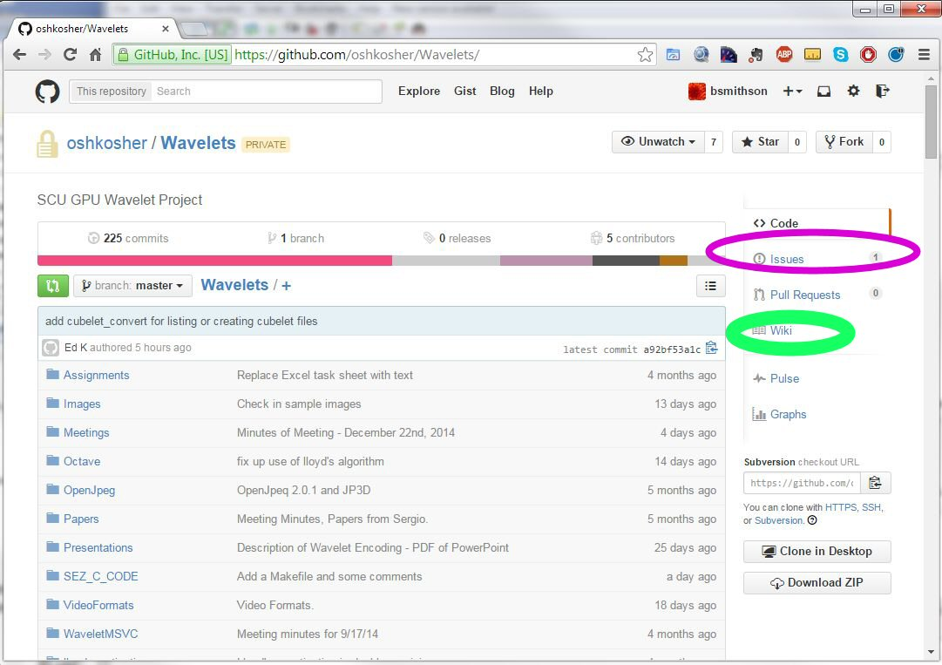

First we will look at an issue tracker. As a group we will agree upon where we want to be in 2 week increments. Assignments will be added to the Issue tracker with a “task” label, and a milestone of 2 weeks.

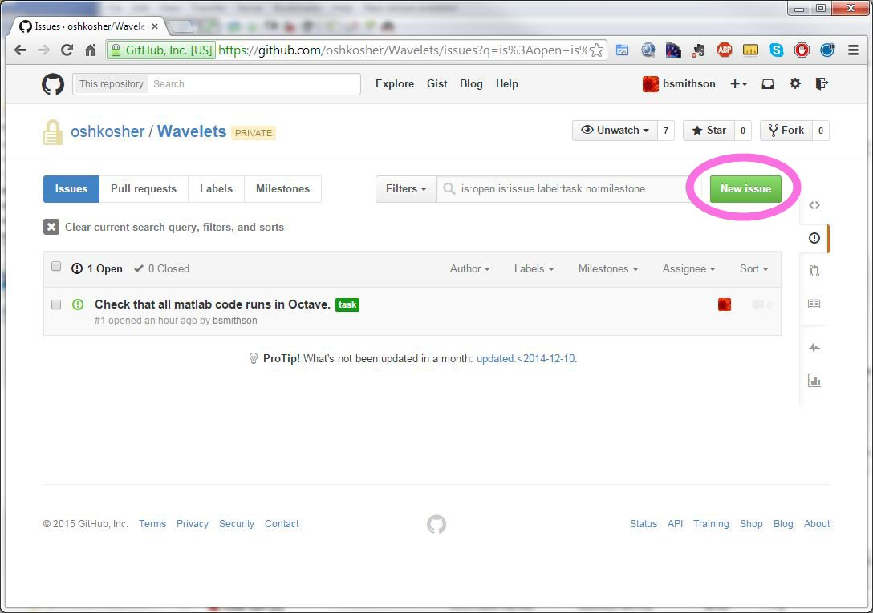

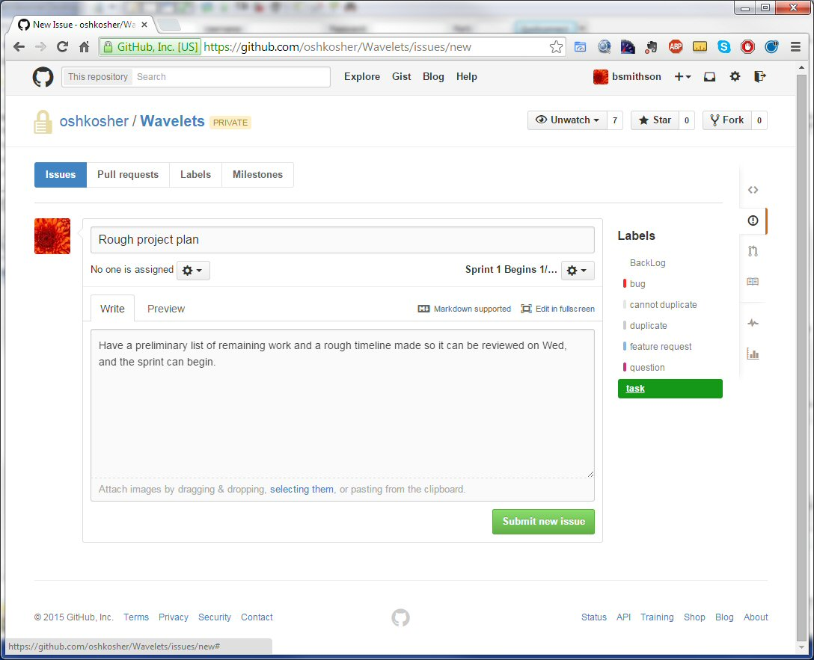

While the implementation phase is going on, any bugs found, or feature requests will go into the issue tracker with the label “backlog”. The sprint will end on a Friday where a breather will commence. No working that weekend, followed by a lessons learned review and setting goals for the next sprint. Then I will add the key tasks to the issue tracker, many of which will probably just change their label from backlog to something else. I will also add the key milestones.

Clearly separating implementation from changing goals will prevent implementers from thrashing. The sprints are short enough that we can complete them as targeted at the beginning of the sprint before changing course. It will also result in clearer goals by having some time to reflect on them before a course change.

I will take care of project level entries, but each team member should feel free to add their own work breakdown structure as tasks in the issue tracker. Your dashboard will allow you to view any tasks assigned to you, or submitted by you, and many other data filters for seeing where we are in the project are available. Additionally, anyone can add a comment to an issue.

## Sharing Information Using a Wiki

When you click on “Wiki” on the Dashboard, you will see this. From here you can edit a page, or add a new page.

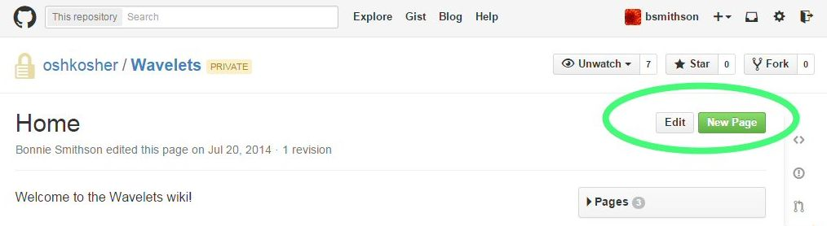

The following shows how new pages are added.

When you select new page you will go to an editor. See the toolbar on the page that has “h1”,”h2”,”h3”, etc?

Those buttons will allow you to enter Wiki notation for heading 1, heading 2, or heading 3. The next button allows you to enter a hyperlink – these are all commonly used as they in MS Word. But this isn’t a WYSIWYG editor. To see how it looks before you save, you can select “Preview”.

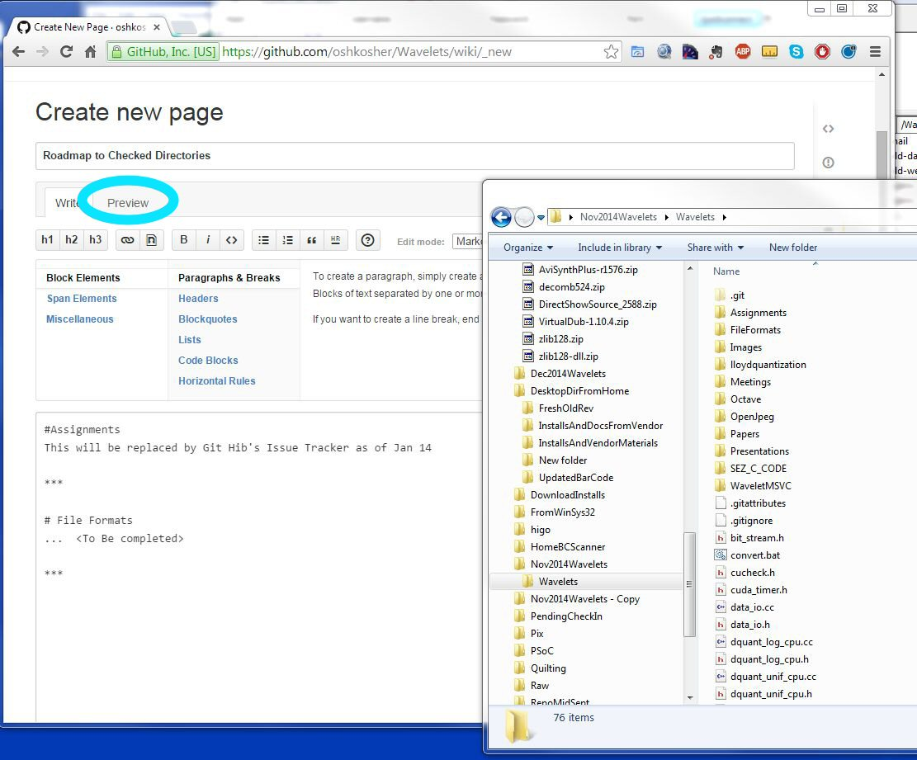

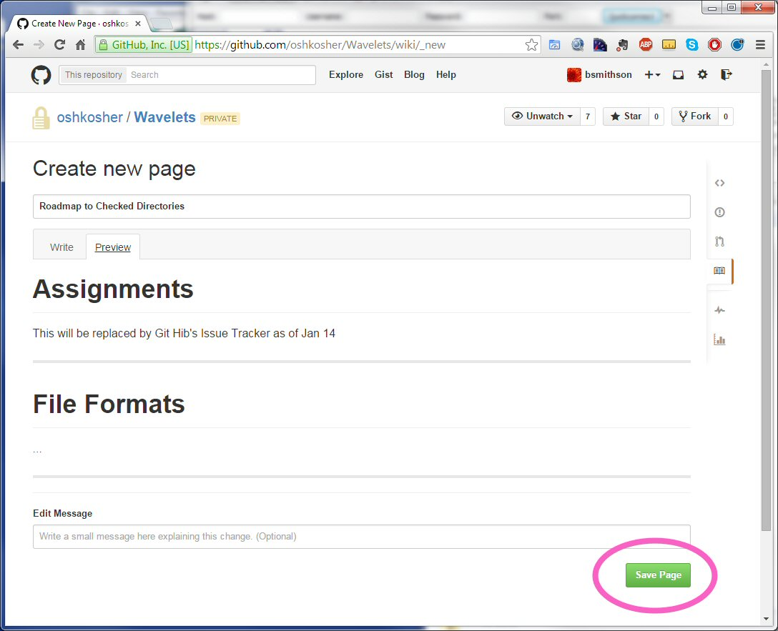

If you like the way it looks you can save the page. Otherwise you can go back to edit or cancel.

Here is the screen that resulted after saving the page that was edited above. Notice that its title appears in the pages pull down now.

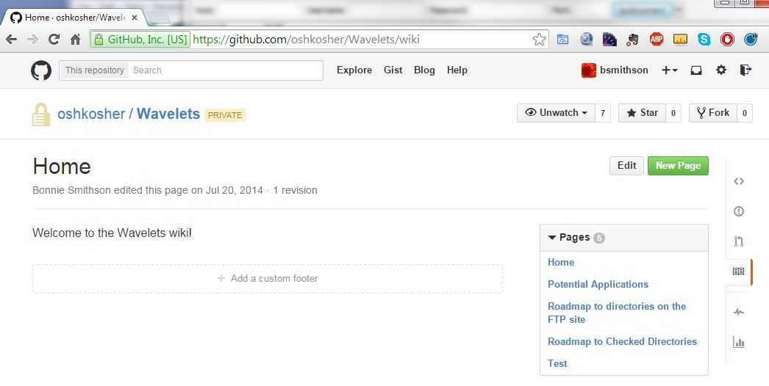

You can add comments to any page. If you get a question two times, considering answering the second time via a Wiki page. It will be much more efficient if everyone on the team can keep up with changing information by just knowing where the current version is in the Wiki.